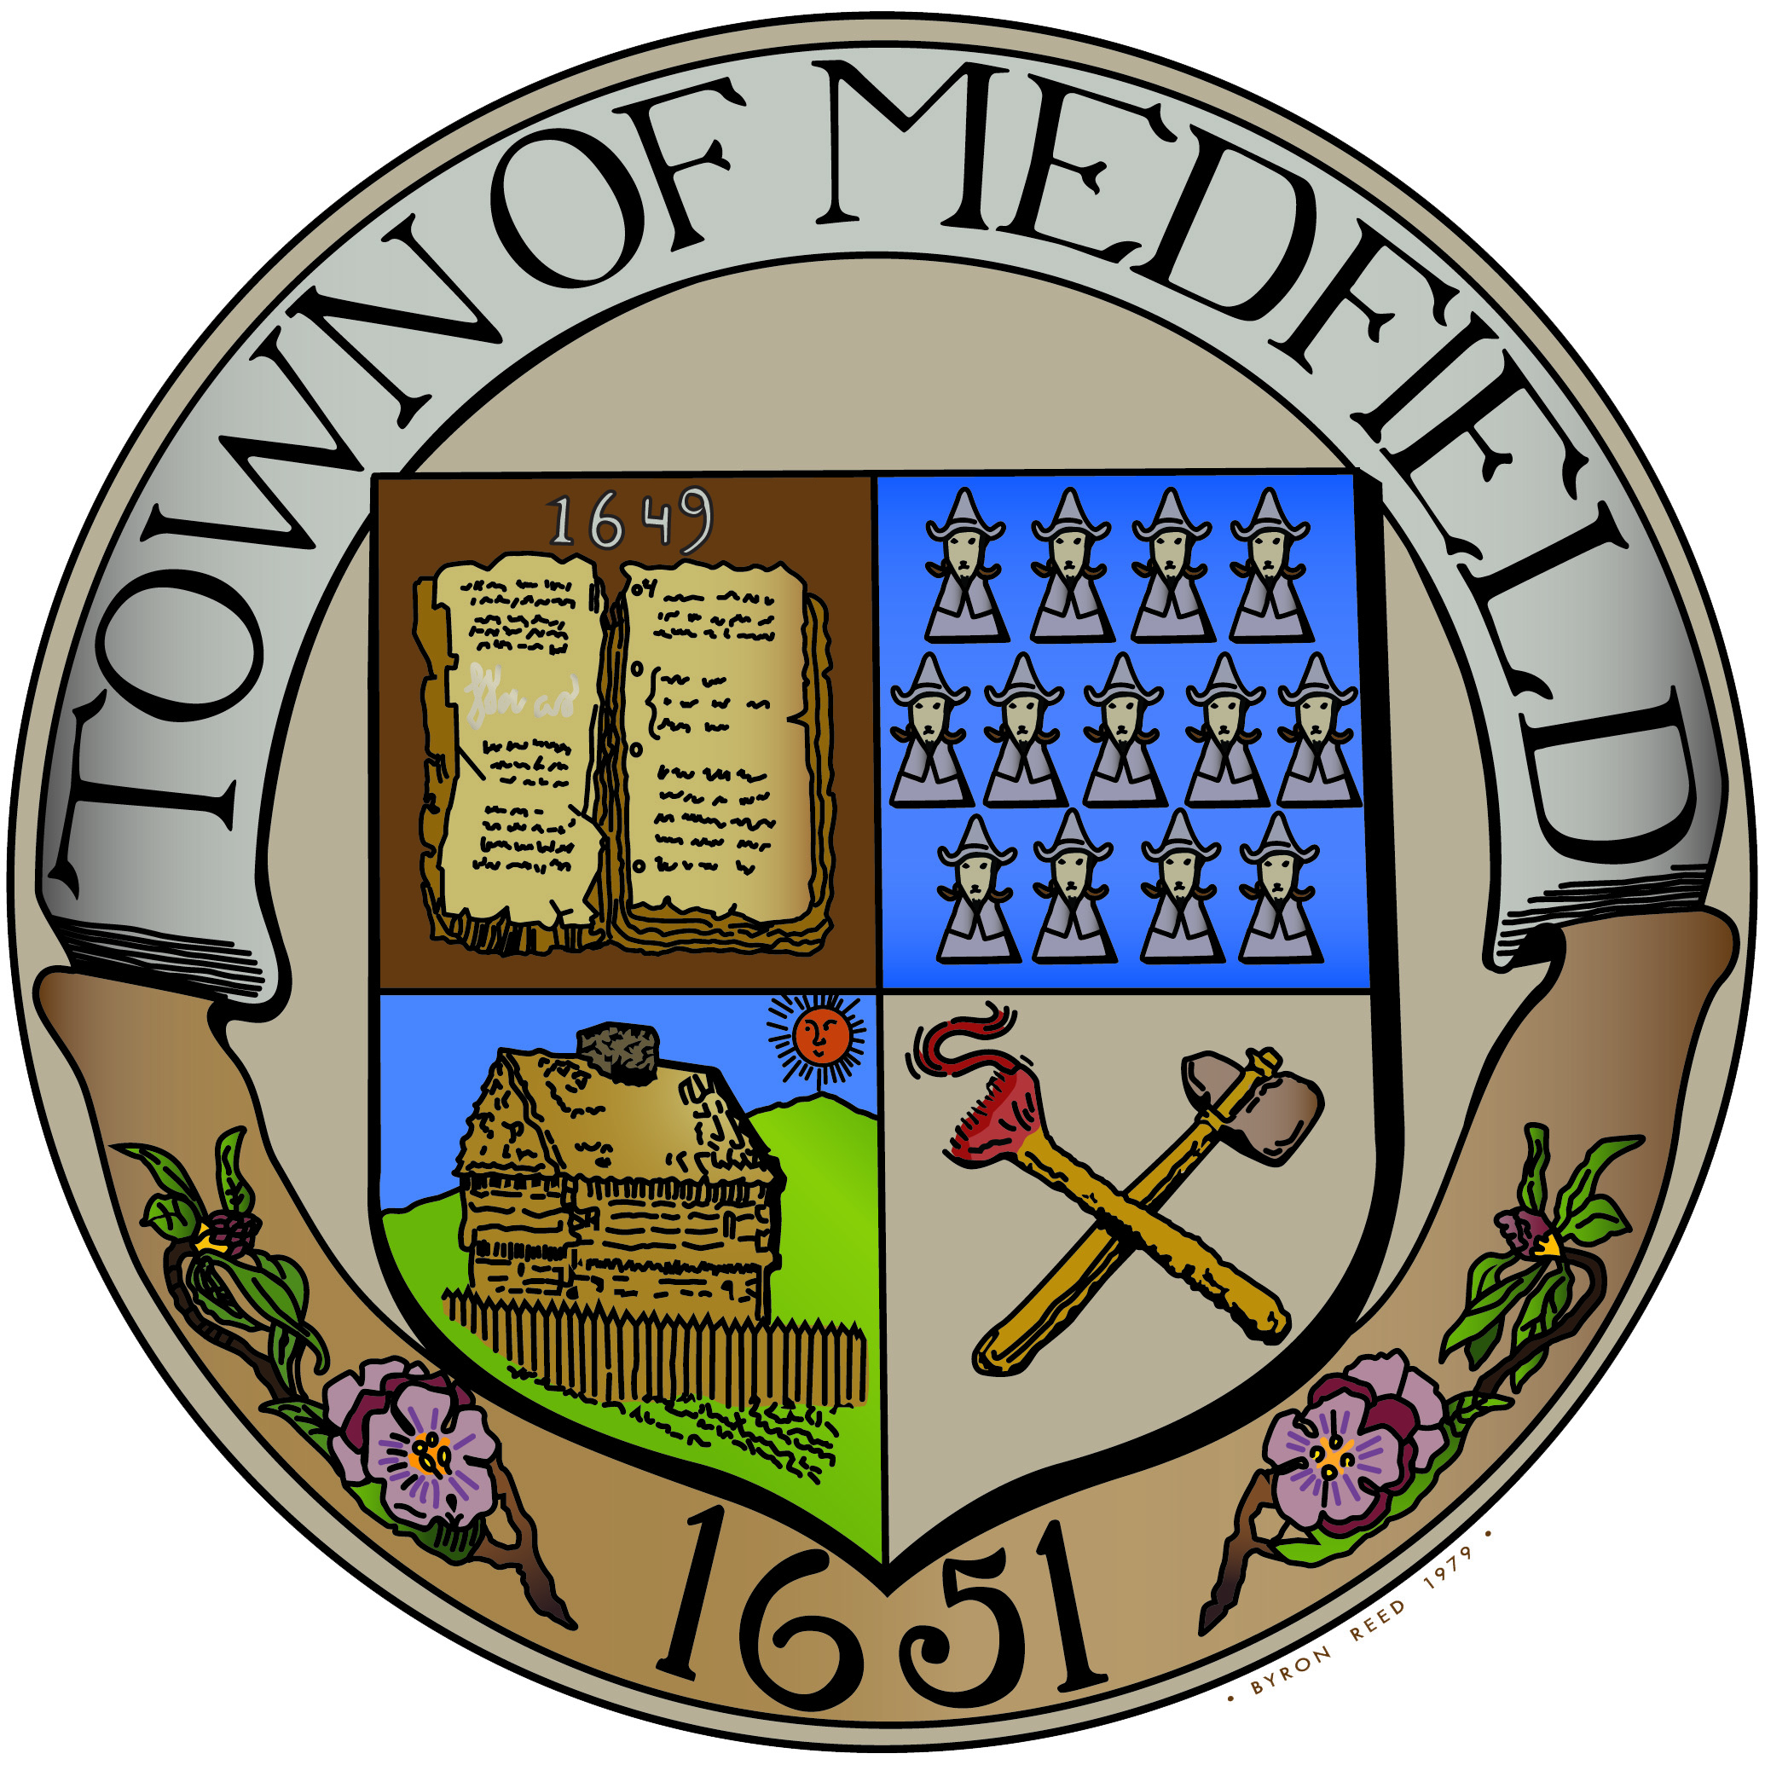
TOWN OF MEDFIELD
Office of the

BUILDING DEPARTMENT

Phone (508) 906-3005 Fax (508) 359- 6182

Gary D Pelletier, CBO
Building Commissioner/
Zoning Enforcement Officer

MEMORANDOM Updated 4/28/2020

CLARIFICATION OF CONSTRUCTION ACTIVITIES AND INSPECTIONS DURING COVID-19 PANDEMIC

- Per Exhibit A of Governor Baker’s 3/24/20 order, Plumbers, Electricians and other Construction workers are considered Covid-19 Essential Service providers.
- All permitted construction activities in the Town of Medfield are allowed to continue without restriction, but are required to follow the State Mandated COVID-19 Guidelines for Construction Work
- All Building Permits are recommended to be submitted on-line, however if submitting paper permits, please drop off in the green mailbox behind town hall, and please include a valid email address on the application. Completed permit applications will be processed within 30 days in accordance with 780 CMR.
- ALL Inspection requests must be submitted by email to sallison@medfield.net
- Minimal Field Inspections (Plumbing, Gas, Electrical, Building) will be conducted until after 5/18/2020 in order to protect the Inspectors and the public and adhere to social distancing mandates.
- Alternative means of verifying compliance with applicable codes will be evaluated case by case by the inspector with jurisdiction in an effort to allow work to continue while ensuring compliance with the codes and life safety measures.
- All 110 Periodic Inspections will be postponed until further notice

Please contact the Building Dept. by email with any questions.

