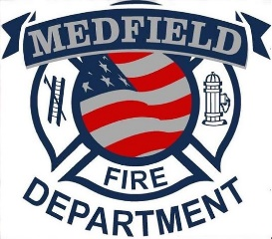
- Rapidly growing town and department
- 1400+ calls annually
- 2 ALS ambulances
- New station
- 24 Hour Shifts 1-2-1-4 Rotation
- Rate Range: $31.77 - $38.11/hr
- Educational incentives

In medic school? Apply with us!

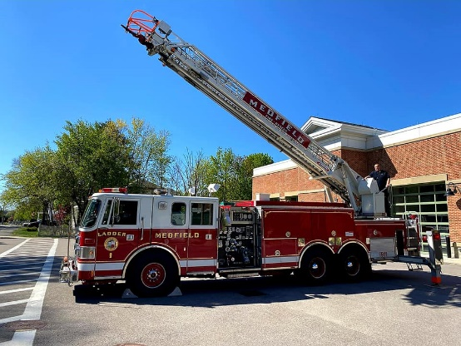
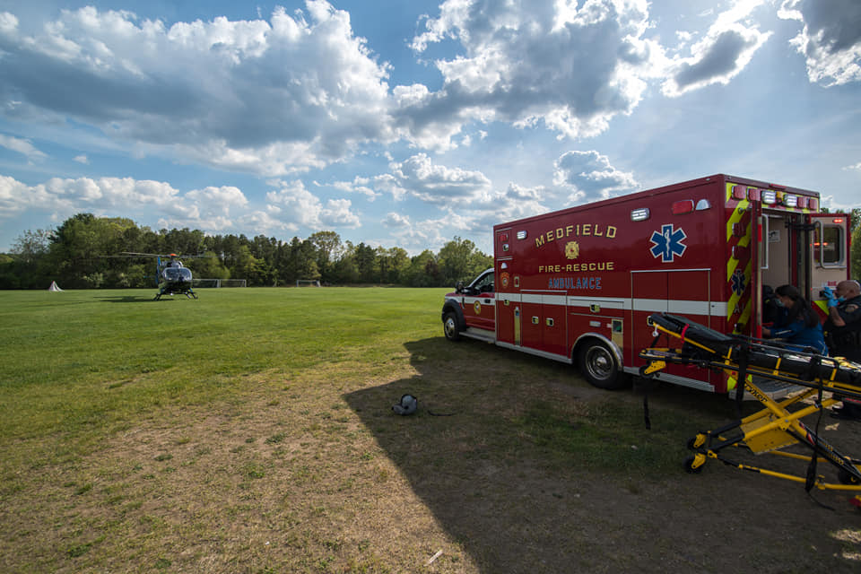
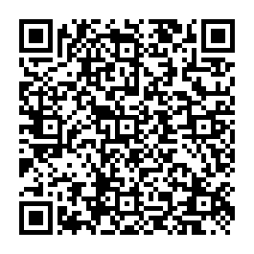
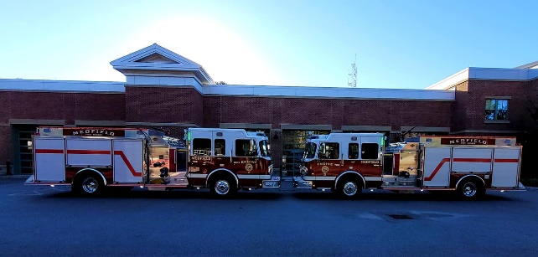
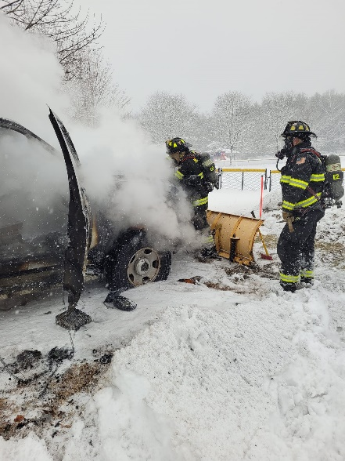
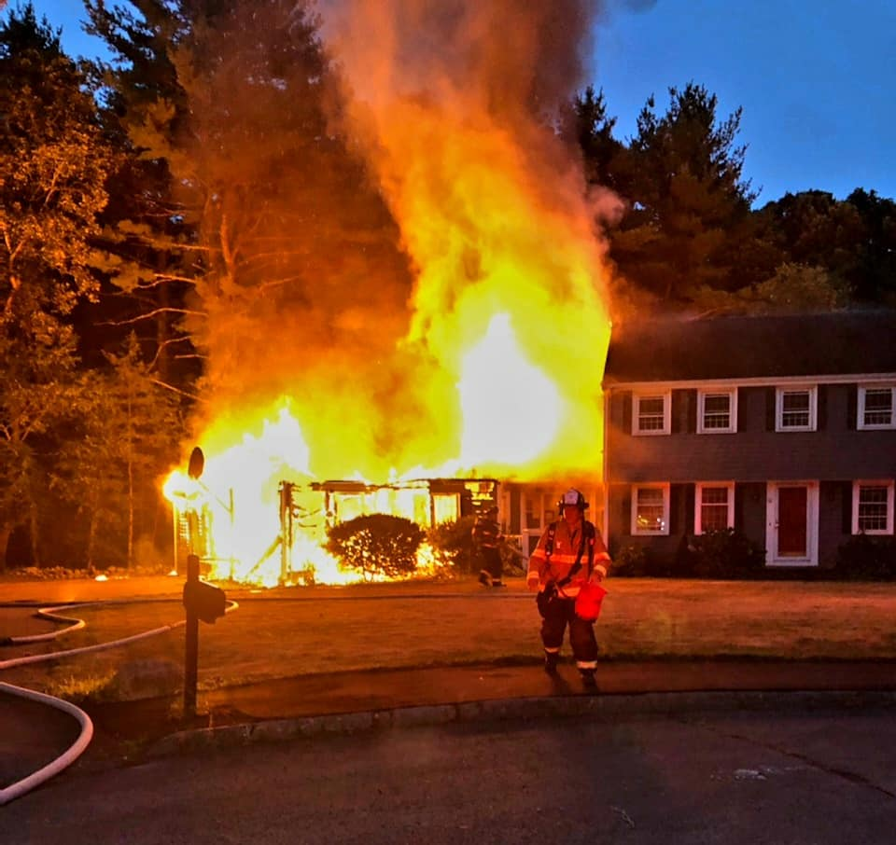
Scan QR code for full posting

