Omega Ventures Inc
55 Loring Street
Westwood, MA 02090
617-970-2403
www.myfirsthome.info

Chapter 40B Affordable Property
Resale Application

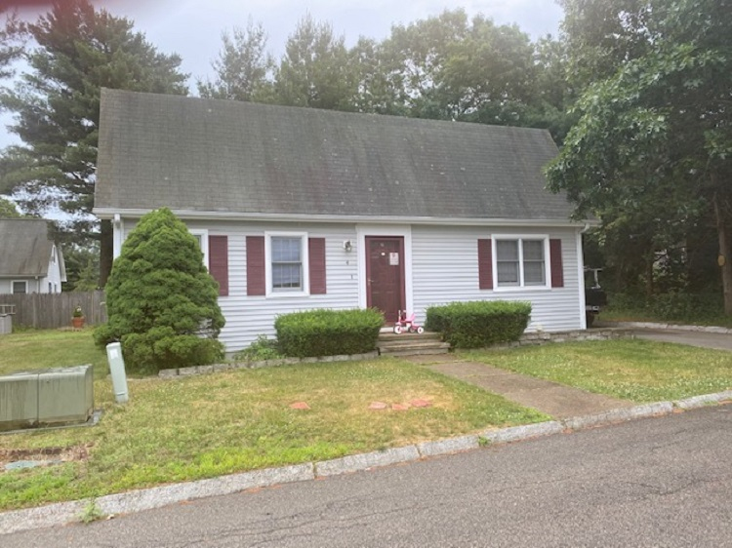

4 John Crowder Rd. Medfield, MA 02052

Packet Includes:
Household Eligibility Form
Disclosure Form
Application Checklist

Applications will be reviewed on a first-come, first-served basis. Only complete applications (unless instructed differently) will be reviewed and approved.

Household Eligibility Form

Eligibility Criteria
- Household cannot exceed the annual income of:
  - 1 Person - $67,400 2 Person - $77,000 3 Persons – 86,650 4 Persons - $96,250
- Household cannot have more than $75,000 in assets.
- Applicants must be first-time homebuyers (have not owned a home in last 3 years)*

Applicant Information

Name:

Address:

City: State: Zip Code:

Telephone: Email:

Co-Applicant Information (if applicable)

Name:

Telephone: Email:

Household Information
Please list ALL household members, regardless of age, who will occupy the affordable home:

Name Date of Birth Relationship

- Displaced homemakers, single parents and households over the age of 55 do not have to be first-time homebuyers, but must sell their current property in order to purchase the unit. (The Department of Housing and Community Developments definition of displaced homemakers and single parents will be used, as published in the Comprehensive Permit Guidelines. These definitions are available upon request.)

First-Time Homebuyer
Have you owned a home or a joint interest in a home in the past three years from the date of this application? □ YES □ NO

If yes, please explain:

Real Estate Agent Contact Information (if applicable)

Name: Agency:

Telephone: Email:

How did you hear about this property? ______________________________________________

Pre-Approval Information
We recommend working with a local bank or credit union for your mortgage financing. Also, please note that FHA& VA do not approve loans for Chapter 40B properties.

Please provide a copy of your preapproval letter.

Lending Institution/Bank: Amount of Pre-Approval:

Date of Pre-Approval: Amount of Down Payment:

Income Information
Please list sources of income for all household members. Income includes gross wages or salary, retirement account income withdrawals, self-employment income, veteran’s benefits, alimony/child support, unemployment compensation, Social Security and supplemental income, pension/disability income, and dividend income. Please note any recent significant changes in amounts received.

Please provide documentation of all income, including:
- Five most recent pay stubs
- Federal Tax Returns for the last three years
- W2s for the most recent year
- Social Security/benefit award letter
- Pension/retirement documentation
- Child support/alimony award or proof of receipt

Source of Income Household Member Amount per Year

If there are additional sources of income, please attach a separate page.

Employment Information

Household Member: Employer Name:

Position/Title: Date of Hire:

Household Member: Employer Name:

Position/Title: Date of Hire:

Household Member: Employer Name:

Position/Title: Date of Hire:
If there are additional employers, please attach a separate page.
Asset Information
Please list the asset information for all household members. Assets include liquid assets, such as checking or savings accounts, stocks, bonds, the cash-value of retirement accounts, cash gifts, and other forms of capital investments, excluding personal property, automobiles, government sponsored down payment assistance programs, equity accounts in homeownership programs or state assisted public housing escrow accounts.

Please provide documentation of all assets, including the most recent monthly statement for all accounts.

Household Member: Bank:

Account Type: Last 4 of Acct. #: Balance:

Household Member: Bank:

Account Type: Last 4 of Acct. #: Balance:

Household Member: Bank:

Account Type: Last 4 of Acct. #: Balance:

Household Member: Bank:

Account Type: Last 4 of Acct. #: Balance:

Household Member: Bank:

Account Type: Last 4 of Acct. #: Balance:
If there are additional assets to list, please attach a separate page.

Gifts
Will the household be receiving a cash gift from a friend or family member to help with the purchase of this property? □ YES □ NO

Name of Source: Relationship to Applicant:

Amount of Gift:

If receiving a gift, please include a letter signed by the donor stating that the amount and that the contribution is a gift.

Certification
I certify that all the information and documentation provided for this application is true and complete to the best of my knowledge. I further understand that:
- All information is subject to verification by Monitoring agency and inaccurate information may lead to disqualification from the application process.
- I will provide additional information as requested and failure to do so in a timely manner may lead to disqualification from the application process.
- Applications will be reviewed in accordance with monitoring agency Buyer Selection and Approval Process.

______________________________
Applicant Name

______________________________ _______________
Applicant Signature Date

______________________________
Co-Applicant Name

______________________________ _______________
Co-Applicant Signature Date

Disclosure Form

Please check and fill in the following items that apply to you.

- I/We certify that our household size is _______ persons.

- I/We certify that our annual household income is ________________. All sources of income from all household members has been included.

- I/We certify that my/our total liquid assets do not exceed the asset limit.

- The household size listed on the application form includes only and all the people who will be living in the residence. I/We intend to use the property as our primary residence as long as we own the property.

- I/We certify that the information contained in this application is true and accurate to the best of my/our knowledge and belief under full penalty of perjury. I/We understand that perjury will result in disqualification from further consideration.

- I/We further authorize the monitoring agency to verify any and all income, employment, asset, or other financial information. I/we authorize any employer, landlord or financial institution to release any information to monitoring agency, as the project’s monitoring agency, for the purpose of determining the eligibility of this household eligibility to purchase this property.

- I/We understand that it is my/our obligation to secure the necessary mortgage for the purchase of the home and that all expenses, including closing costs and down payments, are my/our responsibility.

- I/We understand that submitting this application does not guarantee that I/we will be able to purchase this property. I/We understand that the application will be reviewed in accordance with CHAPA’s Buyer Selection and Approval Policy. I/We have reviewed and understand that process.

- I/We have been provided and have reviewed the Chapter 40B affordable housing deed rider and DHCD policies that will apply to this property should I/we purchase it. I/We agree to the restrictions and to abide by all monitoring agency policies, including those regarding residency, resale, refinancing, and repair.

Applicant Signature Date

Co-Applicant Signature Date

Application Checklist & Submission Instructions

Your application is NOT considered COMPLETE without the following documents. Incomplete applications will not be eligible for first-come, first-served review.

- Fully completed and signed Household Information Form
- All applicable income documentation, including:
  - Five most recent pay stubs,
  - Federal tax returns for the last three years
  - W2s from the most recent tax year
  - Social Security or benefit award letter
  - Retirement or pension documentation
  - Child support/alimony award or proof of receipt
- All applicable asset documentation, including:
  - 5 most recent checking and savings account bank statements
  - Recent retirement/brokerage statements
  - Gift award letter
- Pre-approval letter from a bank or mortgage company indicating your household qualifies for a fix rate mortgage sufficient to purchase the property
- Signed Disclosure Form

Submitting Your Application:
Please submit the complete application to:

Omega Ventures Inc. 55 Loring Street, Westwood, MA 02090
Email: aviglaser@comcast.net

After You Submit:
- Your application will be reviewed on a first-come, first-served basis. Only complete applications will be reviewed. Other complete applications received after an incomplete application is received will be reviewed first.
- If your application is not complete, every effort will be made to notify you of any additional information or documentation needed, but CHAPA cannot guarantee any review of applications to request additional documentation. PLEASE THOROUGHLY REVIEW YOUR APPLICATION BEFORE SUBMITTING.

